Based on the dataset provided, which includes information on customer purchases with fields such as CustomerID, Country, Product, PurchaseChannel, AgeGroup, and AmountSpent, here are some Excel Pivot Table assignment ideas:

* Sales Analysis by Country and Product Type:
  + Objective: Create a Pivot Table to analyze the total amount spent on each product type in each country.
  + Steps: Group data by 'Country' and 'Product', then sum the 'AmountSpent' for each category.



* Channel Preference Analysis:
  + Objective: Determine which purchase channel (Online or In-Store) is more popular for each age group.
  + Steps: Use 'AgeGroup' and 'PurchaseChannel' as row and column labels, respectively, and count the number of purchases in each category.



* Average Spending Analysis:
  + Objective: Calculate the average amount spent per purchase in each country.
  + Steps: Group by 'Country' and use the average function on 'AmountSpent'.



* Product Popularity by Age Group:
  + Objective: Identify which product is most popular among different age groups.
  + Steps: Use 'AgeGroup' as a row label and 'Product' as a column label, then count the number of purchases for each product in each age group.



* Comparative Sales Analysis:
  + Objective: Compare the total sales (amount spent) between Online and In-Store channels across all countries.
  + Steps: Create a Pivot Table with 'PurchaseChannel' as the row label and 'Country' as the column label, then sum the 'AmountSpent'.



* Top Customers Analysis:
  + Objective: Identify the top 5 customers in terms of the total amount spent.
  + Steps: Group data by 'CustomerID' and sum the 'AmountSpent', then sort in descending order and apply a filter to show the top 5 customers.



* Country-wise Sales Distribution:
  + Objective: Create a Pivot Chart to visually represent the distribution of sales across different countries.
  + Steps: Use 'Country' as a row label and sum the 'AmountSpent', then create a Pivot Chart (like a bar chart) to visualize the data.



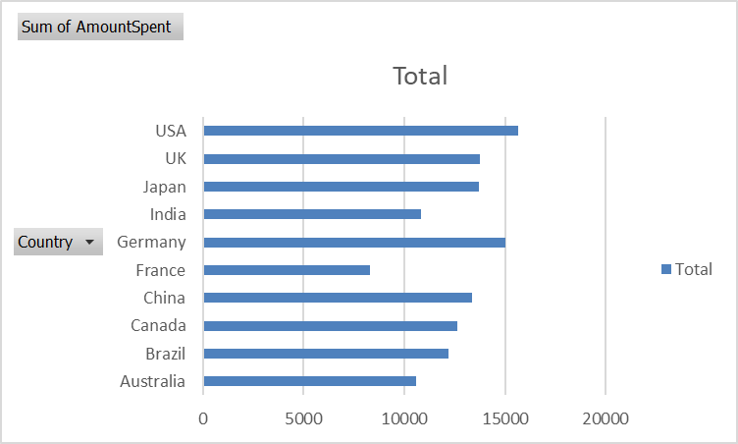

* Product Sales Trend Analysis:
  + Objective: If the dataset includes a date field (not present in the sample data), analyze the sales trend of each product over time.
  + Steps: Use the date field as a row label, 'Product' as a column label, and sum 'AmountSpent' to see trends over time.



